CENTRAL WEBPAGE LOG IN FUNCTIONALITY

NEW OPTION VIA “ABOUT” MENU  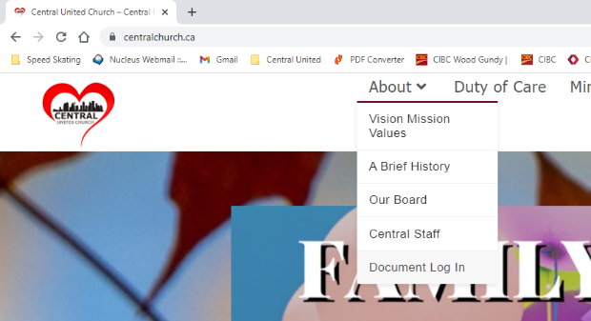  This is the route to the new Document Repository. Users will be able to Log In and access the forms that have been made electronically available, from one location. | 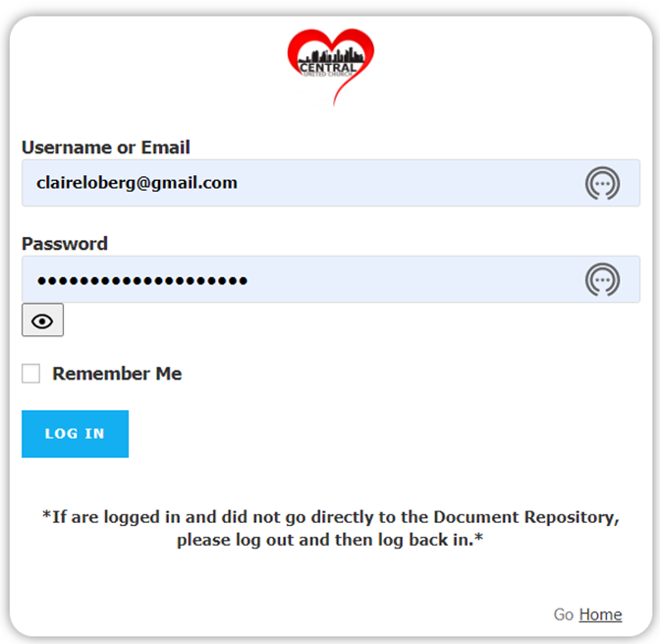
DOCUMENT REPOSITORY

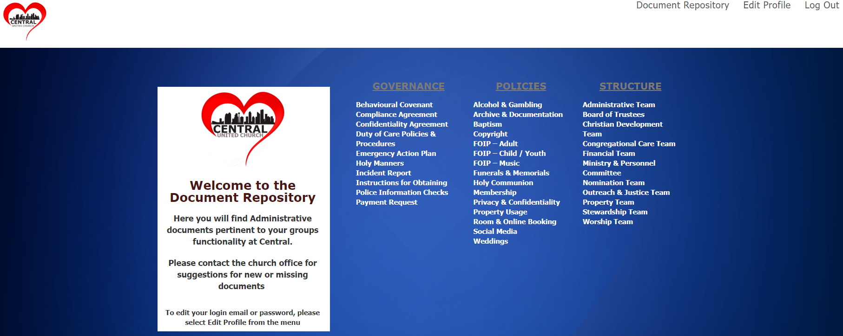
- Documents will be added as they are converted to a pdf printable or pdf fillable format.  - Click on the link for a document and it will open up in a separate tab in your browser.  - From within the Document Repository, users also have the ability to Edit their Profile. This allows changes to email addresses and passwords. | EDIT PROFILE  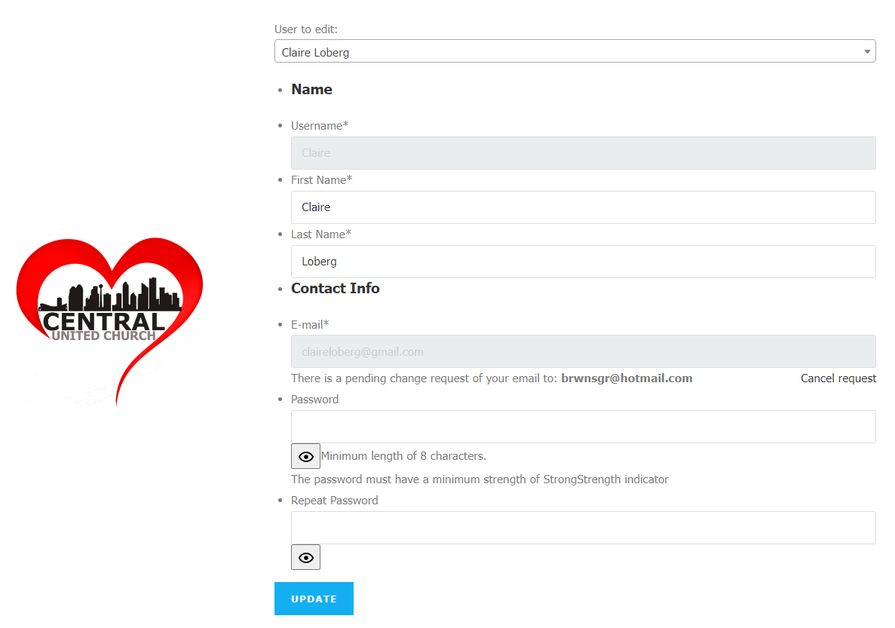  Users can edit their own Profile without having to request an update from Administrators.  ** User Names cannot be changed **
ADMINISTRATOR VIEW  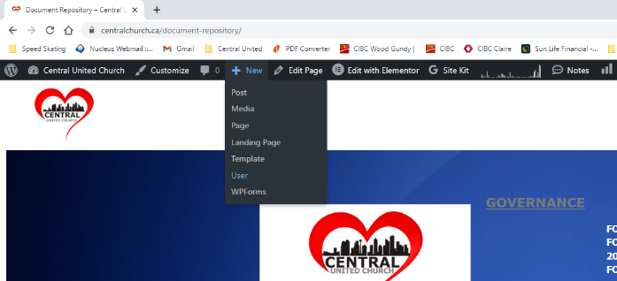  Administrators have a slightly different view and have the ability to Add New Users.  New Users will receive a Password Reset notification email from WordPress@centralchurch.ca  Be aware that this email might go into a SPAM or JUNK folder. |  | 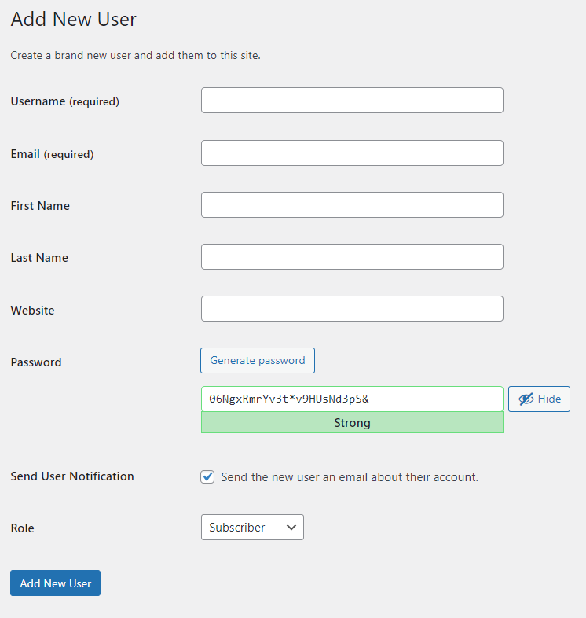
PASSWORD RESET EMAIL  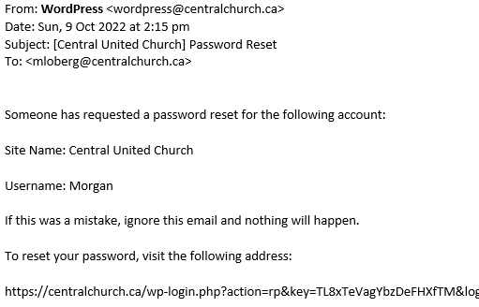 |  | PASSWORD RESET VIEW  